**Investment Analysis of Chinese Stock Market: Strategy Based on P/E Ratio**

**Introduction**

China's stock market is one of the largest in the world, with $13.37 trillion market capitalization and 5011 stocks in A-share. To classify numerous companies listed, the Chinese stock market is divided into several boards: the main board markets of Shanghai Stock Exchange and Shenzhen Stock Exchange, SME board, GEM board, NEEQ board and STAR board. In this analysis, we specifically focus on the historical performance of stocks in main board, SME board and GEM board.

**Database**

This project uses the database form CSMAR with China Stock Market Series and China Listed Firms Research Series, mainly focus on 8 indicators:

1. Stock return, this project chose market trading table and Monthly Return Without Cash Dividend Reinvested field. we consider in Chinese market, dividend reinvest will not generate as cash flow as companies will simply issues more shares, and hence not a part of stock return
2. Market capitalization, market trading table and total market value field.
3. Firm age, China Listed Firms Research Series, equity information table and age of the firm field. We chose this field considering the simplicity and it accurately recorded firm age at one decimal level.
4. Total asset, directly from financial statement, Balance Sheet, Total Asset
5. R&D investment, from income statement, R&D expense field.
6. Total income, from income statement, Total Profits. We use the R&D expense and total profit to calculate reinvest ratio more interpretable, since they’re in the same statement.
7. P/E ratio, financial indicators, Relative Value Index, P/E Ratio-TTM. We chose TTM-PE since TTM data smooth out fluctuations in a company's financial performance that may occur in any single quarter or month, reflects the company's financial performance over the past 12 months.
8. P/B ratio, financial indicators, Relative Value Index, P/B Ratio

**Overview**

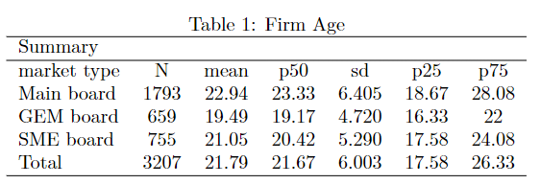

We first construct the table of firm age, we use the data directly from 2021q4 instead of artificially plus one for the variables, since we don’t know whether there are companied taken off A-shares. We can see the firm age intuitively that Main board firms possess higher age, with 23.33 for median and 22.94 for mean age. We also noticed the firms with top quantile ages distribute most difference for the three different market. The p25 only has 2.33-year difference, but p75 comes to 6.08-year difference.

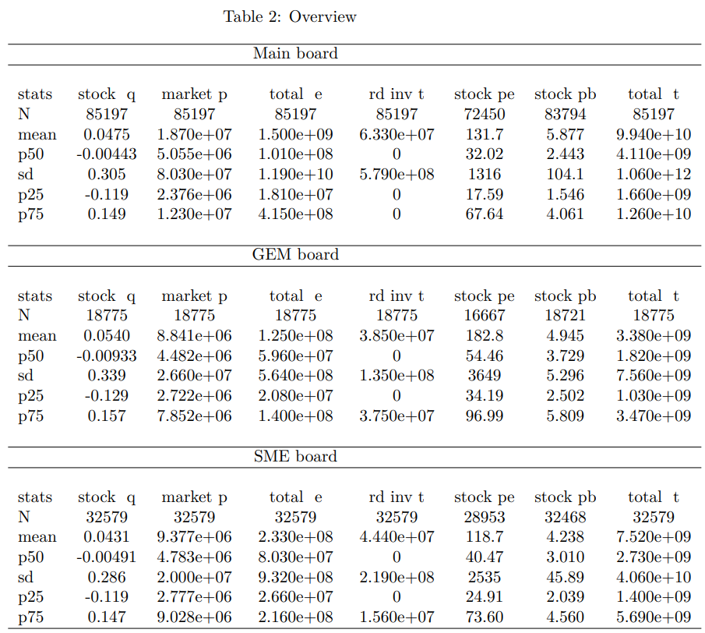

Then we construct the following seven indicators divided into three market type. First, we noted that although the market as a whole is worthwhile of investment, the majority of companies in the three sectors are unable to generate positive returns Rate, with the median being less than 0. Second, the main board, then the SME board, and finally the GEM, have the highest average stock returns. We then pay attention to market capitalization. Stocks on the main board have a far bigger market capitalization than those on the GEM and SME boards, indicating that they are substantially more mature, however they may lose the potential for high growth. We discovered that the market capitalization and total income had relatively high standard deviations, showing that even if the stock market has distinguished most stocks, there are still clear individual disparities within each sector. Individual investments carry a risk that is significantly higher than ETF investments. There are still at least 75% companies that do not invest in R&D, despite the fact that the average value of the stocks on the main board is still rather high. Contrarily, even though the SME board firms and the GEM invest less in R&D, there are more companies that are engaged and possess more percentage in total income. Among these, we cannot assess a company's investment in innovation based just on R&D expenditures. Since R&D is directly financed by the government in the majority of businesses listed on the main board, R&D costs will be presented lower. The median values of PE ratio and PB ratio has the same characteristic as expected. Since main board firms are more concerned with profit margins and cyclical market conditions, they may not be given an overly high PE/PB ratio. GEM and SME boards are more focused on future high development and rapid expansion; thus, they have higher PE/PB ratios.

**P/E ratio and ROE**

P/E ratio (Price-to-Earnings ratio): P/E ratio is a valuation metric that compares a company's stock price to its earnings per share (EPS). It is calculated by dividing the current market price of a company's share by its EPS.

ROE ratio (Return on Equity ratio): ROE ratio measures a company's profitability by calculating how much profit it generates for each dollar of shareholder equity. ROE is calculated by dividing a company's net income by its shareholder equity. A high ROE ratio generally indicates that a company is efficient in generating profits from its equity, while a low ROE ratio may indicate that the company is not using its equity effectively.

This project provided the first method of combining P/E ratio and ROE ratio, we are searching for market with low P/E ratio quarter on quarter and high ROE quarter on quarter

**PEG ratio**

In this project we use quarterly stock return as ROE, and reinvestment ratio is calculated by R&D investment/Total Income, then we can derive:

PEG = PE / (ROE * R&D investment / Total Income)

**Result**

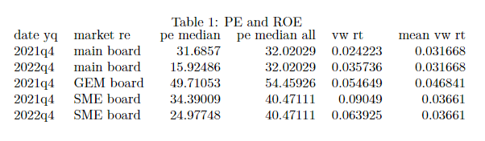

Form table 1, we can see that in 2022Q4, both main board and SME board have significantly lower PE ratio than historical behavior. For 2021Q4, the PE ratio are still below median for all historical PE ratio, it even decreases in SME board and main board. From the perspective of stock returns, the stock returns of the three sectors in the last quarter all exceeded the historical average return rate, and the SME board in 2021q4 has a return rate as high as 9.05%. Combining PE ratio and ROE, this study believes that the current market is in a market with high ROE and low PE, which has high investment potential and should enter the market for investment.

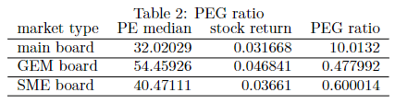

We performed the PEG analysis using the methodology described above. According to Table 2, the main board is in a period of high peg ratio, despite the fact that its PE ratio is lower than that of other boards. However, such a PEG ratio contains a significant bias: as previously discussed, R&D investment in the main board cannot be judged by a single R&D expense, and many government-supported resources are hidden, resulting in a lower profit rate growth rate. As a result, it is not advised to invest in the main board using this report's peg ratio.

The GEM and SME boards' PEG ratios are relatively optimistic. We obtained a very low PEG ratio because the PE ratio at this stage is relatively low compared to the historical PE ratio and R&D investment in the two boards accounts for a large proportion. We believe that when the PEG is less than 0.8, the stock is undervalued, so the GEM and SME boards have high investment value at this stage.



This time-series plot clearly shows that there is a significant rise in 2013 followed by a rapid decrease. We can also see that in 2022q1, the main board and SME board have hit their lowest point in the last 20 years, implying that the entire market is undervalued. Based on this intuitive judgment, the PE ratio should rise, indicating that it is a good moment to invest in the market.

**Strategy**

Based on the analysis, two key indicators that investors should pay attention to are the price-earnings (PE) ratio and return on equity (ROE). A high PE ratio indicates that the market is expecting higher earnings growth in the future, while a high ROE suggests that companies are generating strong profits from the capital they have invested.

Investors who are optimistic about the markets' performance could consider taking long positions in index ETFs that track the three markets, such as SSEC, CSI 500. These ETFs may offer good returns in the future as the markets continue to perform well. Additionally, investors may want to overweight their portfolio towards the SME board ETF, given its high return rate in 2021Q4 and potentially higher growth prospects.

However, some investors may be more cautious and prefer to hedge their positions on the main market, which is still uncertain with a high PEG ratio but a low PE ratio. A high PEG ratio may indicate that the market is expecting high earnings growth, but if the growth does not materialize, the stock may be overvalued. Hedging can help to protect against potential losses in such a situation.

It is worth noting that the market is currently almost reaching the upper limit of its PE ratio. As such, shorting the market may not be advisable at this point. When the PE ratio goes back to average levels, stock values are likely to increase rapidly, and investors may end up losing money. Therefore, shorting the market may be a risky strategy at this time.

Overall, the market is always unpredictable, and it is essential to have a well-diversified portfolio that can withstand any sudden shifts in the markets.

**Limitation**

This project identifies three significant biases in the analysis. The first bias is related to the estimate of R&D spending. The analysis relies on R&D expenditure and overall profit figures to calculate the reinvestment ratio, which is a useful metric for measuring a company's capacity to reinvest profits back into its business. However, this approach does not provide an accurate estimate of R&D investment for each company. Additionally, the data has missing values, which further hinders the accuracy of the estimates.

The second bias is related to the calculation of risk-free return. The analysis lacks sufficient data to accurately calculate the risk-free return, making it challenging to determine whether the market return rate differs from the risk-free return, which would imply a higher risk premium. Inflation may also have an effect on the stock market, and if both the price-earnings ratio and the risk-free return rise significantly, it could indicate an inflationary environment.

The third bias is related to the calculation of the market PE ratio. While the analysis uses the median PE ratio as the market PE ratio, constructing ETFs for long-short operations requires the calculation of market value-weighted stock price/market value-weighted EPS. This approach may lead to variations from the median, resulting in significant disparities in the figures.

These biases can have a significant impact on the accuracy of the analysis, making it difficult to draw reliable conclusions from the data. To mitigate these biases, it is essential to use a more comprehensive approach to estimating R&D spending and collecting more data to accurately calculate the risk-free return. Additionally, using a more comprehensive approach to calculating the market PE ratio could help to reduce the disparities in the figures.